1. - As an option you can just run DataEmit.py and PLA.py without command line arguments, it will guide you through the process as shown below !

* If you prefer old way DataEmit <w0,w1,w2>, please use it but NOT DataEmit [w0,w1,w2] which is a bit confused in second version of the hw1.pdf instructions.
* Please feel free to contact me for any questions by 852-92292831 or [hoson@live.hk](mailto:hoson@live.hk) .

Screenshots --

C:>python DataEmit.py



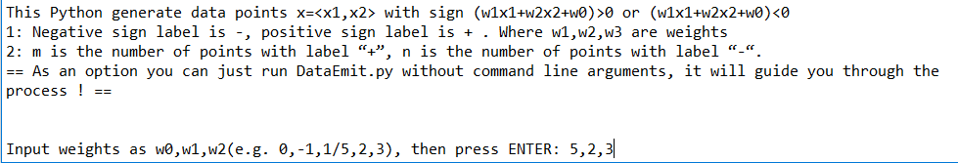

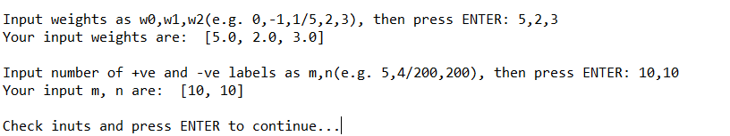

C:>python PLA.py



Furthermore an additional file called “DataEmit&PLA.py” that just put two Pythons together for ease of use.

II) Directory:

SourceCode - all source codes

ReferencePlotsDatas - all reference plots and datas with naming format stated in the report

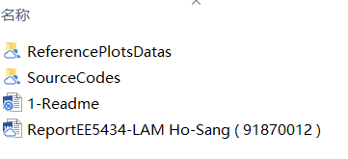

III)

""" Anaconda Installation Steps """" . \*The Pythons also work in Colab notebooks.

======================================

IDE and Python Spyder Installation Guide

1) Download Anaconda from: https://www.anaconda.com/download/

2) Install all libraries under the INSTALLED envirnoment. e.g. (base)C:\Users\Admin>, [ drive name may be different ]

> conda install -c conda-forge matplotlib

> conda install -c anaconda pydot pandas openpyxl xlrd

Screenshots:

